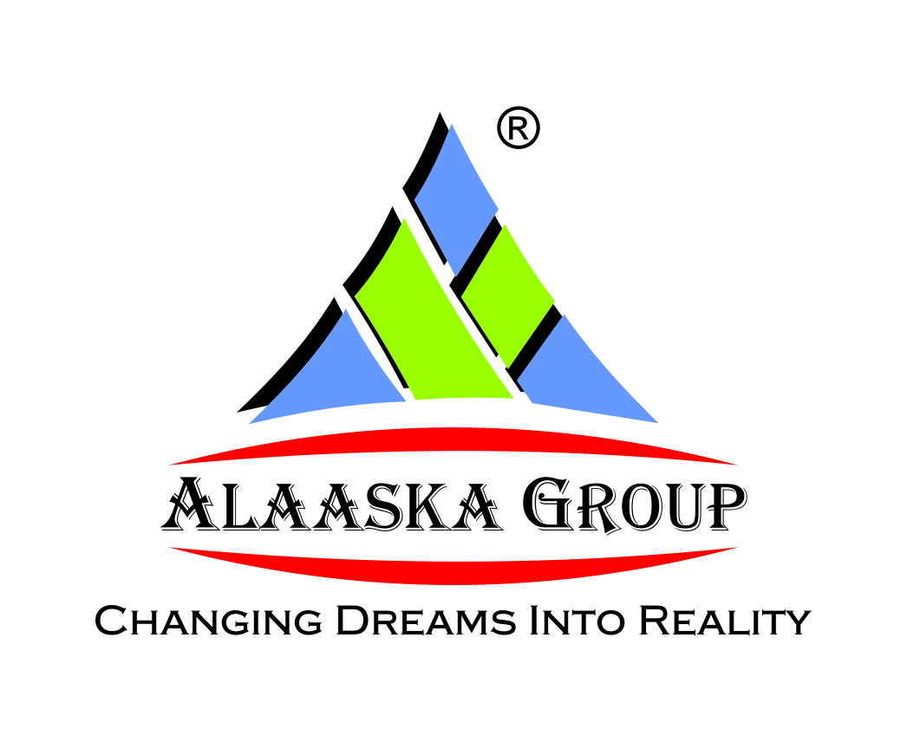

**KEY BENEFITS TO BUYERS:**

* Alaaska Group is Govt. Registered & ISO - 9001 : 2008 (QMS) and ISO – 14001 : 2004 (EMS) Certified renowned developer in Real Estate Sector.
* Alaaska Group is the Member of IGBC ( Indian Green Building Council ).
* United Estate Baruipur Integrated Township Project is trusted, marketed and supported by DHFL Property Services Ltd.
* Alaaska Group is one of the most trusted brands in the realty space because of its believes in providing quality homes, timely execution and customer satisfaction.
* Baruipur is one of the fastest growing area in South Kolkata because of many existing and up coming High-profile Residential and Commercial Developments.
* Both Residential and Commercial freehold property available within United Estate Baruipur Residential Integrated Township Project.
* Distance only 35 minutes from Gariahat Crossing , 25 minutes from Kamalgazi Crossing and 30 minutes from Tollygunge.
* Location on 30’ (feet) concrete road in the heart of natural greenery and pollution free environment.
* All modern amenities are available within United Estate Baruipur Residential Integrated Township Project.
* One of the Biggest & Luxurious Residential Integrated Township project in Kolkata.
* Easy Monthly Installment facility available without interest.
* One of the most Affordable Housing Township Project for Ultra Luxuary Villas in Kolkata.
* Special Discount available for Govt /Private job Employees and Senior citizens.
* Extra Discount available on instant registration.
* 24x7 Security, Water & Electricity facilities available.
* Easy access and well-connected to Metro Station, Railway Station, Bus Stand , Auto Stand, School, College, Market, Banks, Police Station, Hospital, Post Office ,Resorts and Parks.
* No making charges for Private Covered Car park, Private Garden and Private Roof Top Garden Terrace in Villas.
* Private Swimming Pool & Private Servant Quarter facility available with extra charges in Villas.
* Interior decoration facility available with extra charges.
* Super built-up area cost is not applicable in Villas.
* On annual basis minimum 20 % price hike benefit on property value.
* Property reselling assistance available for our clients.
* Boundary with iron gate and green hedges in each Villas.
* Floor plan internally can be modified in Villas as per client need within limitation.
* “Don’t wait to buy land, buy land and wait.” – By Will Rogers
* “The best investment on earth is earth.” – By Louis Glickman
* “Buying real estate is not only the best way, the quickest way, the safest way, but the only way to become wealthy.” – By Marshall Field

K:\office\alaaska entire project files\new email details jan 2017\alaaska project details new 2017\united estate baruipur logo.jpg