Toostee’s El-Dorado
The Monalisa of Real Estate

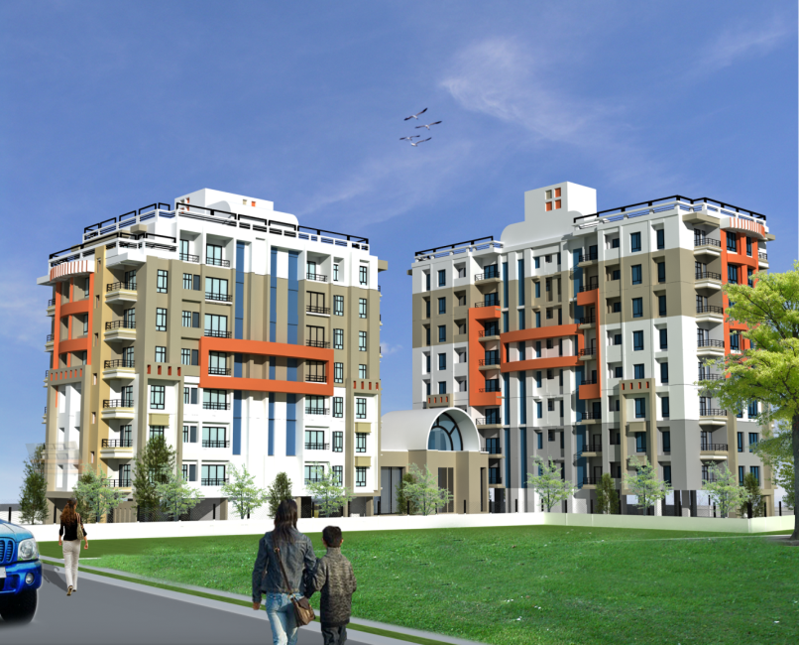

Site Address:
Bikash Nagar, Vidya Mandir Path
Opp. Maharishi Vidyamandir H.S. School
Lalmati, Borsajai, Guwahati-781029
Building N.O.C No.: GMDA/BP/469/06032008/156
Promoter: TOOSTEE CONSTRUCTIONS PVT. LTD.
Ph. No: 98640-97288, 98640-88961
Fax: 0361- 2517987
E-mail: toosteeconstructions@gmail.com
Introducing
» Modular Kitchen
» L.P.G Reticulated System
&
»Individual Modern Security System
At no extra cost

Specifications:
1. Structures: Earthquake resistance R.C.C. frame structure with shear wall as per code. Structure complies with seismic zone-V specification.
2 .Walls: External walls weather coat paint finish and internal walls to be finished with plaster of paris.
3. Floor: Vitrified tile flooring for all rooms and balconies except for toilet floor. Common area, lobby, staircases shall be finished with marble and kota stone.
4. Doors: First class local wood door frame with flush door shutter shall be provided for all doors except for the opening from drawing room to the balcony. Three Track aluminum sliding door shall be provided for the opening between Drawing room and Balcony.
5. Windows: Sliding aluminum windows with glass shutter.
6. Toilet: Toilet floors shall be finished with Anti-skid tiles and ceramic tiles for walls up to the door level. Toilets shall have sanitary ware of reputed brand and CP fitting of Jaguar or equivalent. Both the toilets shall have both hot and cold water provision.
7. Kitchen: Vitrified floor tiles with Granite kitchen platform and 600mm high Ceramic wall tiles on top of the kitchen platform. Kitchen will be provided with fully finished modern modular design with stainless steel kitchen sink.
8. Electrification: All concealed wiring fire resistant ISI marked copper wire and modular switches with adequate numbers of light and fan points in all the rooms. Provision for AC point in master bedroom and also for other electrical appliances shall also be provided.
9. Security System: Individual modern security system to control and restrict unwanted visitor.
10. A society and multi-occasion hall in Block-I.
11. A fully equipped fitness center in Block-II.
12. Introduction of L.P.G Reticulated System at no extra cost, which is convenient to use and customers need not worry about refill booking and dry-outs. No storage of cylinders at customer’s premises and hence availability of more usable space in kitchen.
13. Spacious Jogging track in the premises itself.
14. Each Block will be provided with two lifts.
15. Water supply arrangement from deep tube well with adequate capacity overhead tank and common underground reservoir.
16. Standby generator shall be provided for emergency power supply for common facilities as well as limited power supply to each flat/unit.
17. Arrangement for Compound Lighting.
18. Standard Fire Fighting arrangement.
19. Security post at the entrance.
20. Residential accommodation for service staff.
21. Compound wall and gate, Concealed telephone and cable TV wiring, common toilet at the ground floor.
22. Plantation programme on the 66% open area shall be taken up much before the initiation of the project to create greener and cleaner environment giving an almost sylvan look.

